**ReactJS – HOL 5**

**Questions & Answers –**

1. **Explain how to clean up and push back to remote Git**

**Ans -** Cleaning up means making sure your working directory and staging area are tidy — no uncommitted changes, no stale branches, and everything in sync.

**Example:** # See what’s changed

git status

# If you have unwanted local changes, discard them

git restore <file> # Discards changes for a specific file

git restore . # Discards changes for all files

# If you want to keep changes but not commit yet, stash them

git stash

# Delete unused local branches (replace branch_name as needed)

git branch -d branch_name # Safe delete (only if merged)

git branch -D branch_name # Force delete

#Push your changes to the remote

git push origin master

**Hands-On:**

1. **Verify if master is in clean state.**

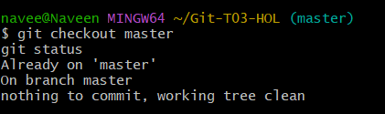

1. **List out all the available branches.**

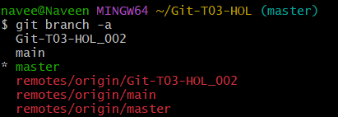

1. **Pull the remote git repository to the master**

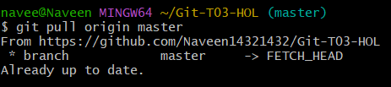

1. **Push the changes, which are pending from “Git-T03-HOL_002” to the remote repository.**

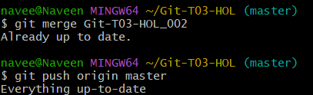

1. **Observe if the changes are reflected in the remote repository.**

